1. Create a shell script to print the HTTP error code of guvi.in & print, the success/failure message based on the error code response

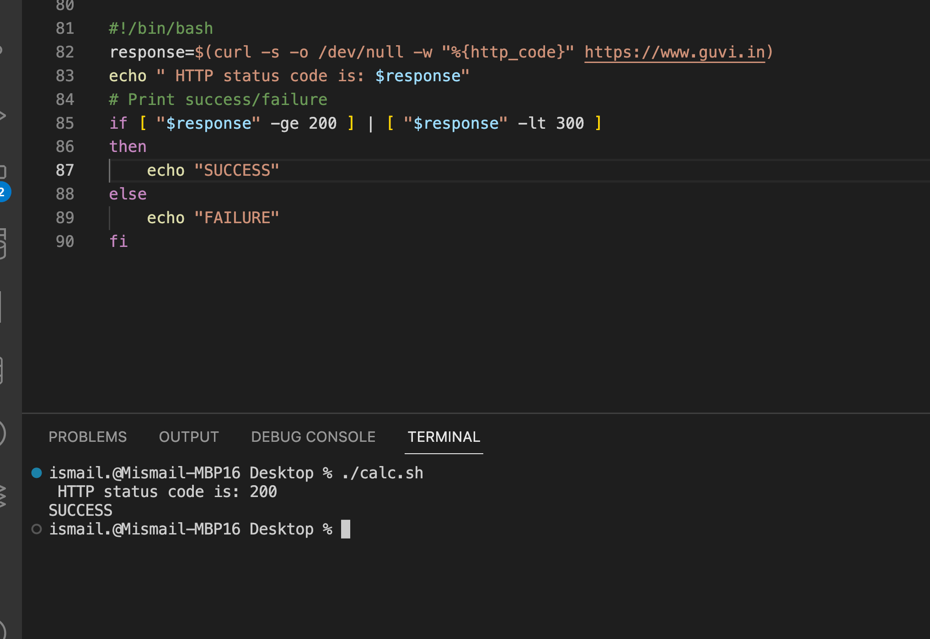

Given a file, replace all occurrence of the word "give" with "learning" from 5th line till the end in only those lines that contain the word "welcome"

**root@ubuntu-host ~ ➜ vi testfile.txt**

**root@ubuntu-host ~ ➜ cat testfile.txt**

**Line 1**

**Line 2**

**Line 3**

**Line 4**

**Please welcome and give your best**

**This line says welcome**

**We will give**

**welcome to give and learn**

**root@ubuntu-host ~ ➜ sed '5,${ /welcome/s/give/learning/g }' testfile.txt > output.txt**

**root@ubuntu-host ~ ➜ cat output.txt**

**Line 1**

**Line 2**

**Line 3**

**Line 4**

**Please welcome and learning your best**

**This line says welcome**

**We will give**

**welcome to learning and learn**

**root@ubuntu-host ~ ➜**